**Step 1:**

Endpoint: <https://spiralogics.ai/samchat/auth/token>

**Request:**   
- Method: POST  
- Content Type: x-www-form-urlencoded  
- Parameters:  
  - `username` (string): The user's username.  
  - `password` (string): The user's password.

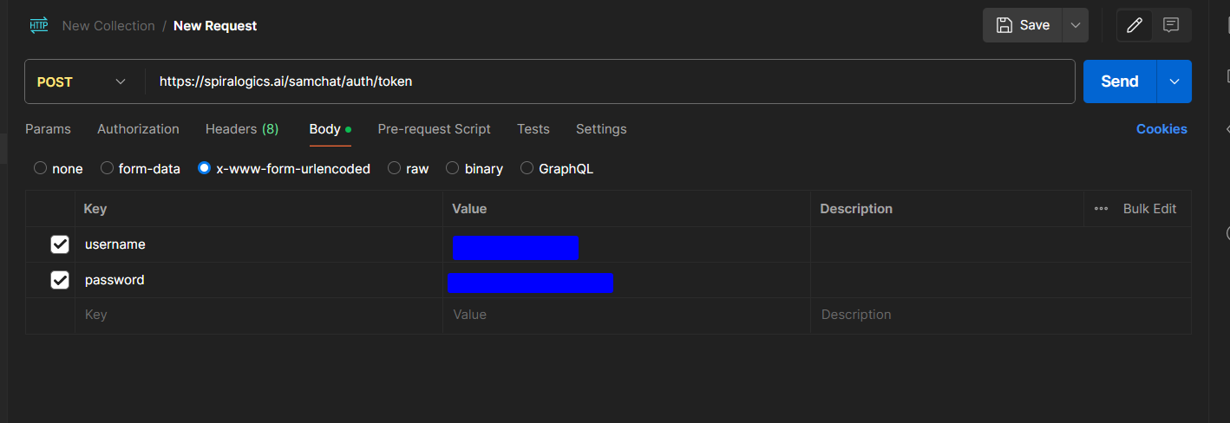

**Response:**   
- On Success (Status Code: 200):  
  - Content Type: application/json  
  - Response Body:  
    {  
      "access_token": "string",  
      "token_type": "string"  
    }  
- On Failure (Status Code: 401 or other error codes):  
  - Content Type: application/json  
  - Response Body:  
    {  
      "detail": "Error message"  
    }

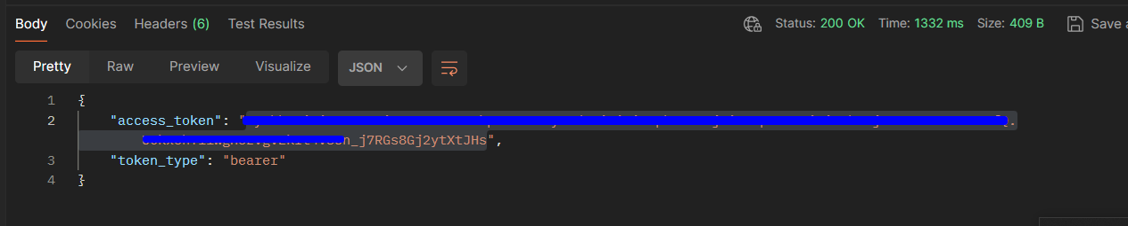

**Step 2:** (Copy the token and save it)

Endpoint: <https://spiralogics.ai/ask>

**Request:**  
- Method: POST  
- Content Type: application/json  
- Authorization: Bearer token required  
- Request Body:  
  {  
    "prompt": "Question"  
  }

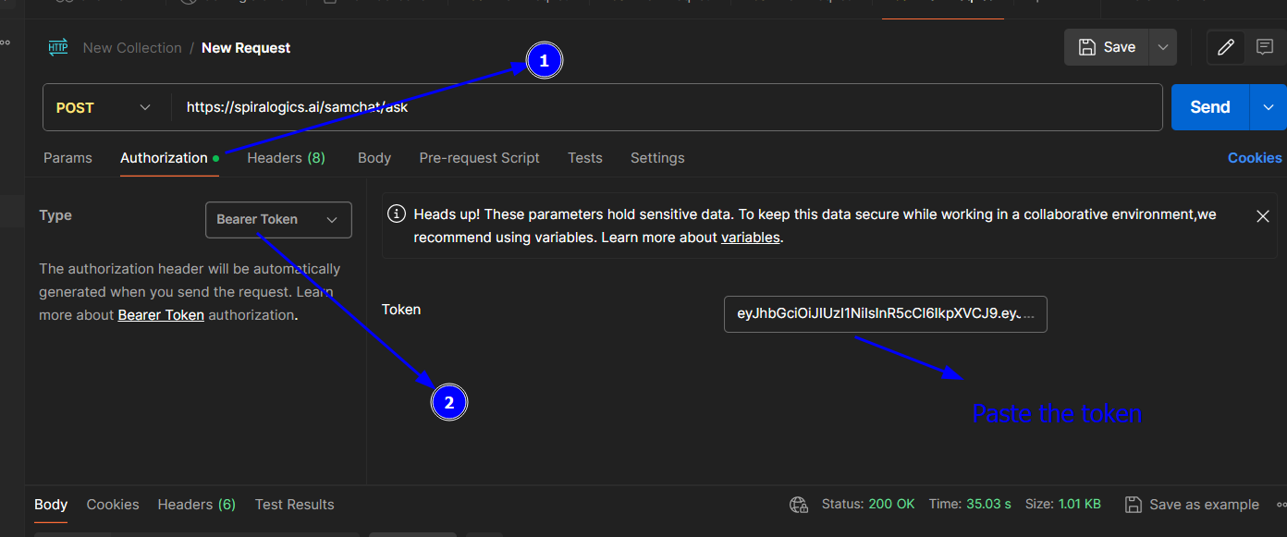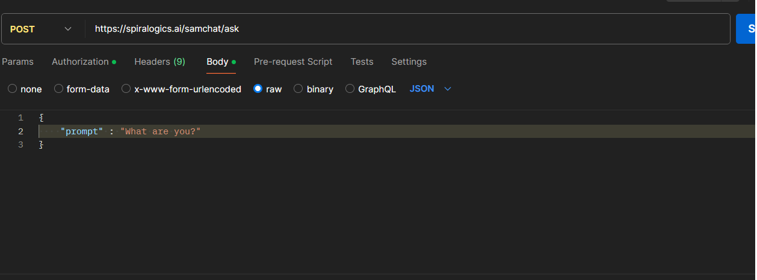

**Response:**   
- On Success (Status Code: 200):  
  - Content Type: application/json  
  - Example Response:  
    "Answer"

